**Delicate Information Exchange Among Representative And Authority**

Gayathri S, Hyshwarrya J D, Keerthana P N, D.Jennifer

***Abstract****-* **The principal point is to give a more secure climate to touchy information exchanges between the representative and position to forestall information spillage if any. This application gives a dispersed application administration and utilizations blockchain innovation to help it. The SaaS layer module offers a cloud stage administration that permits each party effectively participate in business correspondences by means of web-based interfaces. The proposed shrewd framework is utilized by each party engaging in the exchange of delicate information. Gathering staff data and guides their connections for a total image of client account association. We'll assist you with security plan while making clients, gatherings, and job based authorizations Encryption is an exceptionally nonexclusive term and there are numerous ways of encoding information. Organizations need to accurately execute and oversee encryption. The way in to a decent encryption technique is areas of strength for utilizing and legitimate key administration. Scramble touchy information before it is shared over untrusted networks (ex. Encoded document capacity).**

1.Introduction

Touchy information exchange is secret data that should be remained careful and far away from all pariahs except if they have authorization to get to it. Admittance to touchy information ought to be restricted through adequate information security and data security rehearses intended to forestall information breaks and information breaks. Touchy information can be any kind of data that should be shielded from unapproved admittance to defend the protection or security of an individual or association. It can incorporate any data relating to: Passwords. Encryption keys.

Literature survey

**1.** **A systematic literature review of blockchain cyber security.** Since the publication of Satoshi Nakamoto's white paper on Bitcoin in 2008, blockchain has (slowly) become one of the most frequently discussed methods for securing data storage and transfer through decentralized, trustless, peer-to-peer systems. This research identifies peer-reviewed literature that seeks to utilize blockchain for cyber security purposes and presents a systematic analysis of the most frequently adopted blockchain security applications. Our findings show that the Internet of Things (IoT) lends itself well to novel blockchain applications, as do networks and machine visualization, public key cryptography, web applications, certification schemes and the secure storage of Personally Identifiable Information (PII). This timely systematic review also sheds light on future directions of research, education and practices in the blockchain and cyber security space, such as security of blockchain in IoT, security of blockchain for AI data, and sidechain security, etc.

**2.** **Secure Computation by Secret Sharing using Input Encrypted with Random Number**. Typically, unconditionally secure computation using a (𝑘, 𝑛) threshold secret sharing is considered impossible when 𝑛 < 2𝑘 − 1. Therefore, in our previous work, we first took the approach of finding the conditions required for secure computation under the setting of 𝑛 < 2𝑘 − 1 and showed that secure computation using a (𝑘, 𝑛) threshold secret sharing can be realized with a semi-honest adversary under the following three preconditions: (1) the result of secure computation does not include 0; (2) random numbers reconstructed by each server are fixed; and (3) each server holds random numbers unknown to the adversary and holds shares of random numbers that make up the random numbers unknown to the adversary. In this paper, we show that by leaving condition (3), secure computation with information-theoretic security against a semi-honest adversary is possible with 𝑘 ≤ 𝑛 < 2𝑘 − 1. In addition, we clarify the advantage of using secret information that has been encrypted with a random number as input to secure computation. One of the advantages is the acceleration of the computation time. Namely, we divide the computation process into a pre-processing phase and an online phase and shift the cost of communication to the pre-processing phase. Thus, for computations such as inner product operations, we realize a faster online phase, compared with conventional methods.

**3. Secure Secret Sharing Using Homomorphic Encryption.** Secret sharing is an important means to achieve confidentiality and data privacy. Secret sharing deals with splitting a secret information with various players. The goal of the secret sharing is security of secret, privacy and hiding information. There are numerous techniques available for secret sharing e.g. polynomial, Chinese remainder theorem, vector space, matrix projection. Techniques have characteristics like threshold, proactive, verifiable. Proactive secret sharing scheme allow user to change share in case of doubt of theft. In this work we propose the proactive secret sharing scheme based on homomorphic techniques. Our scheme consists of three phases of share construction, share renewal, share reconstruction. Central authority splits an encrypted secret with each parties using homomorphic property of paillier encryption i.e. subtraction. In renewal process two or more parties relate share with each other for to generated renewed share. In reconstruction process all parties share will be add to central authority then encrypted secret will be generated. Central authority will decrypt encrypted secret using secret key then original secret will be generated. Our schemes unique features is share can be renewed any time, Each party can choose secret of their own choice, If any two parties have same content share then also encrypted share will be different due to non-deterministic property of paillier encryption.

**4. Blockchain based secured information sharing protocol in supply chain management system with key distribution mechanism.** This paper describes how the blockchain mechanism combines with the traditional pharmaceutical supply chain system and to achieve a better SCM system, we present a “blockchain-based scheme” for information sharing securely in the pharmaceutical supply chain system with smart contracts and consensus mechanism. The proposed scheme also provides a mechanism to “distribute required cryptographic keys” to all the participants securely using the smart contract technique.

**5. A Survey on Secured Data Sharing using Ciphertext Policy Attribute Based Encryption in Cloud.** “Cloud based information sharing” is a technique that allows researchers to communicate and collaborate, that leads to major new developments in the field. It also enables users to “access data” over the cloud easily and conveniently. Privacy, authenticity and confidentiality are the three main challenges while sharing data in cloud. “Attribute Based Encryption(ABE), Role Based Encryption, Hierarchical Based Encryption, and Identity Based Encryption”, are types of encryption.

**6.** **Blockchain based secured information sharing protocol in supply chain management system with key distribution mechanism.** This paper describes how the blockchain mechanism combines with the traditional pharmaceutical supply chain system and to achieve a better SCM system, we present a “blockchain-based scheme” for information sharing securely in the pharmaceutical supply chain system with smart contracts and consensus mechanism. The proposed scheme also provides a mechanism to “distribute required cryptographic keys” to all the participants securely using the smart contract technique.

**7.** **A System Architecture of Cybersecurity Information Exchange with Privacy (CYBEX-P).** In this paper, we argue that privacy preservation of shared threat data will motivate entities to share threat data. Accordingly, we propose a framework called CYBersecurity information EXchange with Privacy (CYBEX-P) to achieve this. CYBEX-P is a structured information sharing platform with integrating privacy-preserving mechanisms. We propose a complete system architecture for CYBEX-P that guarantees maximum security and privacy of data. CYBEX-P outlines the details of a cybersecurity information sharing platform.

**8. Blockchain-Enabled Information Sharing Within a Supply Chain**: A Systematic Literature Review. The goal of this paper is to identify and understand the impact of blockchain technology for information sharing within a supply chain. The decentralized nature of blockchain technology offers a high level of transparency and has gained the attention from various sectors to deploy this technology.

*III Proposed methodology:*

The proposed shrewd framework is utilized by administrator or authority engage in the creation of touchy information. The last delicate information are delivered by the last information overseer or authority individual, and different modules associated with the course of information collection know nothing about the last information.

**Methodology:**

SHA Algorithm, AES Algorithm, Block-Chain Technology.

**SHA ALGORITHM:**

In the area of cryptography and sepulcher examination, the SHA-1 calculation is a tomb designed hash work that is utilized to take a more modest info and produces a string that is 160 pieces, otherwise called 20-byte hash esteem long. The hash esteem in this way created, is known as a message digest which is commonly delivered and created as a hexadecimal number which is explicitly 40 digits in length.

### Characteristics:

* The cryptographic hash capacities are used and used to keep and store the got type of information by giving three various types of qualities, for example, pre-picture opposition, which is otherwise called the principal level of picture obstruction, the second degree of pre-picture opposition and impact obstruction.
* The foundation lies in the way that the pre-picture tomb opposition procedure makes it hard and additional tedious for the programmer or the aggressor to track down the first expected message by giving the particular hash esteem.
* The security, in this way, is given by the idea of a one way that has a capacity that is generally the vital part of the SHA calculation. The pre-picture obstruction is critical to tidy up beast force assaults from a bunch of colossal and strong machines.
* Also, the second opposition strategy is applied where the assailant struggles with disentangling the following mistake message in any event, when the primary level of the message has been unscrambled. The last and generally challenging to break is the crash opposition, making it incredibly difficult for the aggressor to find two totally various messages which hash to a similar hash esteem.
* Hence, the proportion to the quantity of sources of info and the results ought to be comparative in design to consent to the categorize guideline. The impact opposition suggests that finding two distinct arrangements of information sources that hash to a similar hash is incredibly troublesome and along these lines denotes its security.

**Advantages:**

* It gives standard and valid solution to process the data with hash function.
* Data is encrypted using AES and stored in the cloud.
* Block chain is used to connect the hash values.
* QR Code generation.

**AES ALGORITHM:**

## How does AES work?

## The AES calculation utilizes a replacement change, or SP organization, with different rounds to deliver figure text. The quantity of rounds relies upon the key size being utilized. A 128-digit key size directs ten adjusts, a 192-piece key size directs 12 rounds, and a 256-bit key size has 14 rounds. Every one of these rounds requires a round key, however since only one key is inputted into the calculation, this vital should be extended to get keys for each round, including cycle 0.

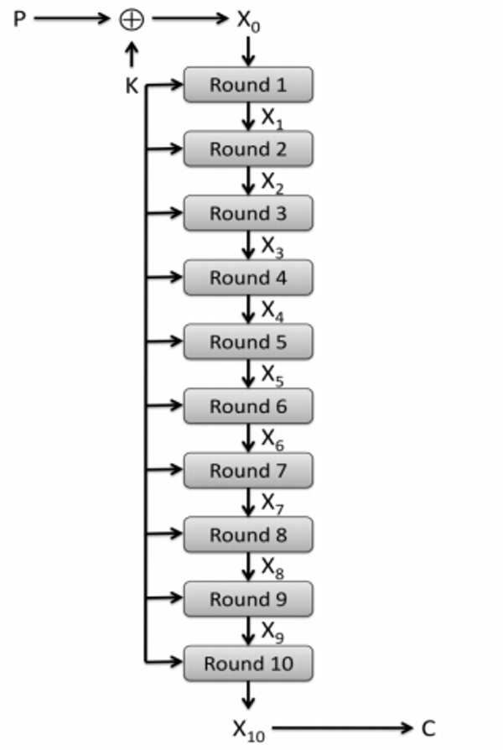

**Fig 5.14**

1. **Substitution of the bytes**

In the initial step, the bytes of the square text are subbed in view of rules directed by predefined S-boxes (short for replacement boxes).

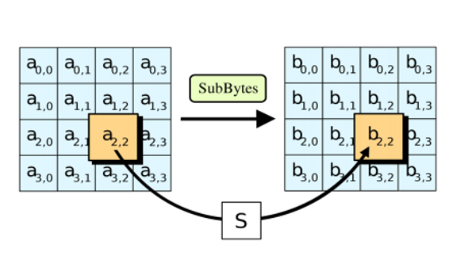

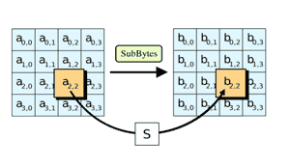

**Fig 5.15**

**2. Shifting the rows**

Next comes the stage step. In this progression, all lines aside from the first are moved by one, as displayed beneath.

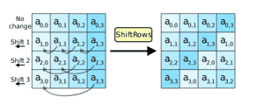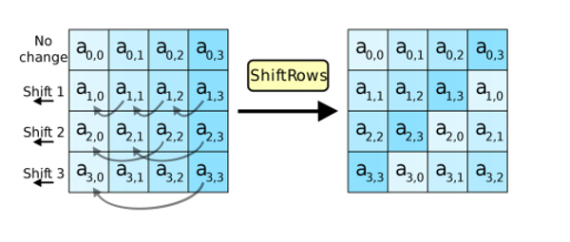

**Fig 5.16**

**3. Mixing the columns**

In the third step, the Hill cipher is utilized to muddle up the message more by blending the square's segments.

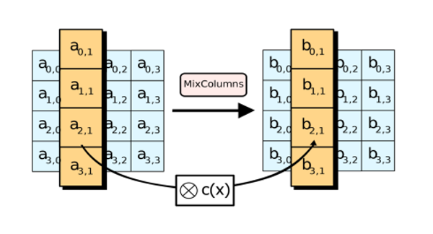

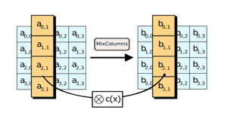

**Fig 5.17**

**4. Adding the round key**

In the last advance, the message is XORed with the separate round key.

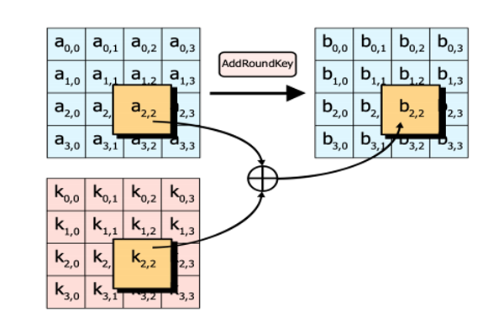

Fig 5.18

When done over and again, these means guarantee that the last ciphertext is secure.

IV System Architecture

The frameworks engineer lays out the essential design of the framework, we propose a Hash code Solomon calculation and we can place a little piece of information in neighborhood machine and haze server to safeguard the security. In addition, in light of computational insight, this calculation can process the dispersion extent put away in cloud, haze, and nearby machine, individually. Through the hypothetical wellbeing investigation and exploratory assessment, the possibility of our plan has been approved, which is actually a strong enhancement to existing distributed storage plot.

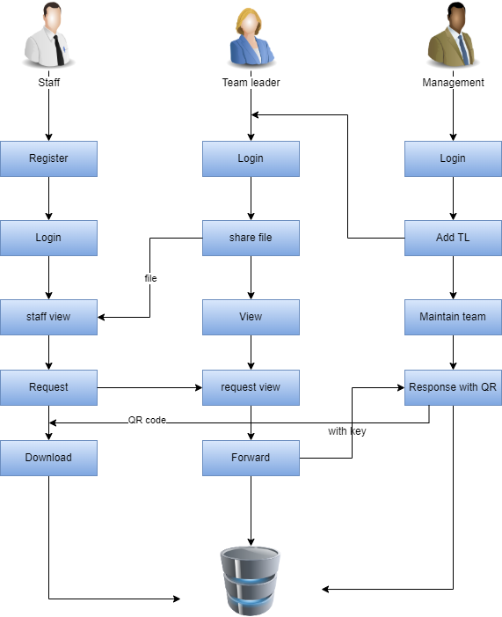

Modules:

**File Encryption:**

The document to be gotten to by the staff is scrambled utilizing AES calculation. The record access consent is mentioned by the staff part. The incomplete unscrambling of the document happens just when the group chief gives the entrance key.

**Hashing and QR Generation:**

Hashing is designed to solve the problem of needing to efficiently find or store an item in a collection. Note: SHA algorithm is used here to generate hash code while a request is given to find a particular file from a database. Since the permission request differs from one staff to another , different hash codes are generated making the access grant integrated QR code generation happens when the user wants the approval for access of a file by management. QR code generation is done using Jquery.

**Permission Grant and Approval:**

MANAGEMENT GENERATE KEY: In this module the administration create key for the staff demand. Since the key for the security reason. After get the key from the executives the staff will download the record with key.

MANAGEMENT RESPONSE: In this module the bank will reaction the information document completely examined information in classification wise view Bank will be liable for your record put away in data set.

Module diagram:

**STAFF FILE REQUEST:**

REQUEST VIEW

DATABASE

REQUEST

STAFFF

**Fig 5.5**

**TEAM LEADER FILE UPLOADED:**

DATABASE

ADD FILE

TEAM LEADER

**Fig 5.8**

**MANAGEMENT RESPONSE:**

DATABASE

MANAGEMENT

STAFF

RESPONSE

**Fig 5.9**

**V RESULT**

This paper proposes a strategy for secure information exchange among associations and its representatives. In this framework, information is moved among unrivaled and delegates utilizing a safe convention. The exchange of documents and information is verified. Encryption calculations have expanded the productivity of safety and realness. Blockchain technique forced the usefulness of the hash capacity to additional increment secure information exchange. Hence, the target of the proposed framework is carried out.

**VI Conclusion**

Information awareness concerns data that ought to be safeguarded from unapproved access or divulgence because of its delicate nature. For some's purposes, that may be Team pioneer, Staff subtleties records. Delicate information is private data that should be remained careful and far away from all untouchables except if they have consent to get to it. Admittance to delicate information ought to be restricted through adequate information security and data security rehearses intended to forestall.

**References:**

[1] P. J. Taylor, T. Dargahi, A. Dehghantanha, R. M. Parizi, and K. K. R. Choo, “A systematic literature review of blockchain cyber security,” *Digital Communications and Networks*, vol. 6, no. 2, pp. 147-156, 2020.

[2] D. Liu and J. Lee, “CNN based Malicious Website Detection by Invalidating Multiple Web Spams,” *IEEE Access*, vol. 8, no. 1, pp. 97258-97266, 2020.

[3] W. Martin, V. Friedhelm, and K. Axel, “Tracing manufacturing processes using blockchain-based token compositions,” *Digital Communications and Networks*, vol. 6, no 2, pp. 167-176, 2019.

[4] D. Puthal, N. Malik, S. P. Mohanty, E. Kougianos and G. Das, “Everything You Wanted to Know About the Blockchain: Its Promise, Components, Processes, and Problems,” *IEEE Consumer Electronics Magazine*, vol. 7, no. 4, pp. 6-14, 2018.

[5] L. Peng, W. Feng, and Z. Yan. (2020). Privacy preservation in permissionless blockchain: A survey. *Digital Communications and Networks*. [Online]. Available: https://doi.org/10.1016/j.dcan.2020.05.008.

[6] N. Kakade and U. Patel, “Secure Secret Sharing Using Homomorphic Encryption,” in *Proc. 2020 11th International Conference on Computing, Communication and Networking Technologies*, 2020, pp. 1-7.

[7] S. Sundari and M. Ananthi, “Secure multi-party computation in differential private data with Data Integrity Protection,” in *Proc. 2015 International Conference on Computing and Communications Technologies*, 2015, pp. 180-184.

[8] S. Jiao, T. Lei, Y. Gao, Z. Xie and X. Yuan, “Known-Plaintext Attack and Ciphertext-Only Attack for Encrypted Single-Pixel Imaging,” *IEEE Access*, vol. 7, no.2, pp. 119557-119565, 2019.

[9] S. Kaushik, and S. Puri, “Online transaction processing using enhanced sensitive data transfer security model,” in *Proc. 2012 Students Conference on Engineering and Systems*, 2012, pp. 1-4.

[10] W. Zheng, Z. Zheng, X. Chen, K. Dai, P. Li and R. Chen, “NutBaaS: A Blockchain-as-a-Service Platform,” *IEEE Access*, vol. 7, pp. 134422-134433, 2019.

[11] F. Casino and C. Patsakis, “An Efficient Blockchain-Based Privacy-Preserving Collaborative Filtering Architecture,” *IEEE Transactions on Engineering Management*, vol. 67, no. 4, pp. 1501-1513, Nov. 2020.

[12] D. Chkliaev, J. Hooman and P. van der Stok, “Mechanical verification of transaction processing systems,” in *Proc. ICFEM 2000. Third IEEE International Conference on Formal Engineering Methods*, 2000, pp. 89-97.

[13] S. Zhang, and J H. Lee. “Mitigations on Sybil-based Double-spend Attacks in Bitcoin,” *IEEE Consumer Electronics Magazine*, vol.7, no. 2, pp. 1-1, 2020.

[14] X. Wang, Q. Feng and J. Chai, “The Research of Consortium Block chain Dynamic Consensus Based on Data Transaction Evaluation,” in *Proc. 2018 11th International Symposium on Computational Intelligence and Design*, 2018, pp. 214-217.

[15] S. Zhang, and J. H. Lee, “A group signature and authentication scheme for blockchain-based mobile-edge computing,” *IEEE Internet of Things Journal*, vol. 7, no. 5, 4557-4565, 2019.